Logging onto Edushire Laptop at Home

Pre-requisites:
- It is essential you log into the Laptop with your credentials on the school network before taking it home, it will not work otherwise.

CONNECT TO HOME BROADBAND
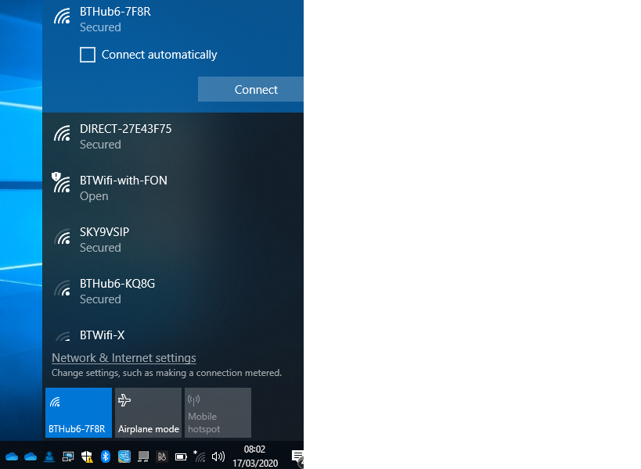
Click on Wi Fi
Select your own home broadband. Select Connect Automatically and then Connect. Enter the password/key for your router. Hint: It’s usually found on a label or removable tab on your router.
You will now need to switch off Aberdeenshire proxies by following instructions below

How to switch off Proxy

Click on Search (Magnifying Glass)
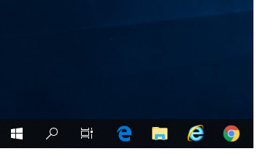
Type in Configure Proxy Server. Select Configure proxy Server Control Panel from the results.

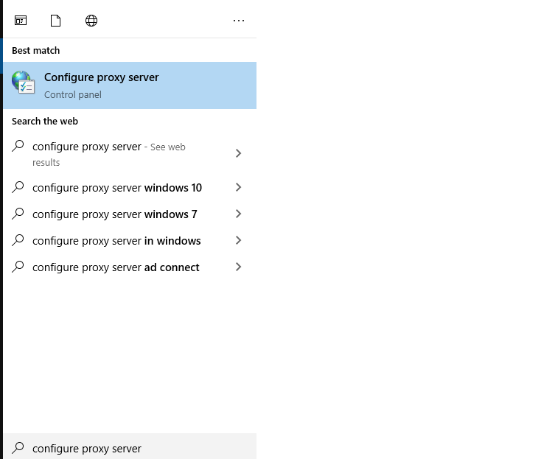
Click on LAN Settings

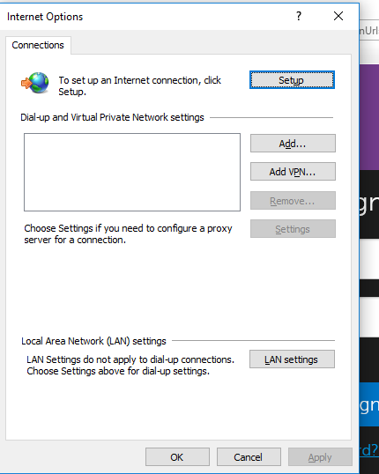

Untick Use a proxy server for your LAN
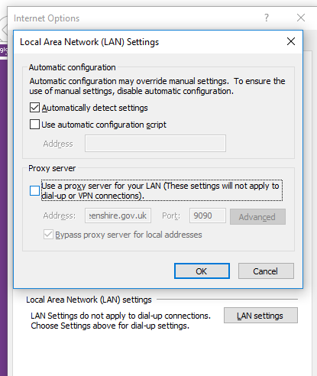

Laptop is now ready to connect to the Internet on your home broadband.

Note: The proxy settings will default to using Aberdeenshire proxy if the laptop is taken back to and logged into at a school/academy. Follow these steps again to disable the proxy for use at home.

